Author: Rowan Temple

Date: 12/06/12

**Stoner installation instructions**

These installation instructions assume you have already installed the enthought python distribution (if you haven’t, copy epd-7.3-1-win-x86.msi from stoner/data/Software/Python onto your hardrive and run it, this will give you all the basic python modules you need). They are also very Windows focussed though they may help with Mac or Linux with a bit of translation.

**Basic Stoner installation (not recommended)**

This is a quicker installation but you will not get the most up to date version and it will not be updated as new changes are made.

1. Copy the PythonCode folder from stonerlab/data/Software/Python onto your local C:\ drive
2. Go into your environment variables (from control panel – system – advanced tab – environment variables) and create a PYTHONPATH variable with a value of C:\PythonCode\src

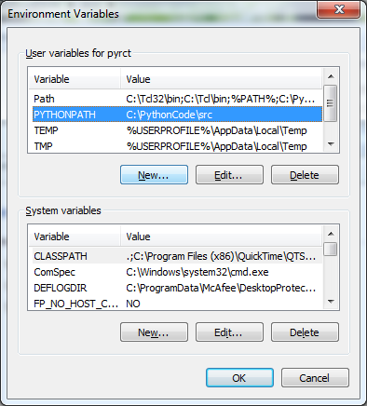

1. You should now be able to use the Stoner module, try calling ‘import Stoner’ from your python terminal to check the installation has worked

**Developers Stoner installation (recommended)**

1. Complete the above basic installation steps
2. Go to Stoner/data/CVS and get the Tortoise and WinMerge installers found there, copy them to your hardrive and install them. Tortoise is a control versioning software that allows you to edit code on your own computer then commit to the server copy when you are ready to release it, you can also easily update your local version to reflect changes made by other developers. WinMerge is a useful piece of software that can quickly compare and merge two text documents. Copy the CVS-Server-key.PPK file to your hardrive, I recommend C:\Windows, you will need this later.
3. Open an explorer window, navigate to C:\PythonCode, right click anywhere on it, you should now get the CVS context menu. This gives all the functionality of the Tortoise program, there is no user interface window as such. 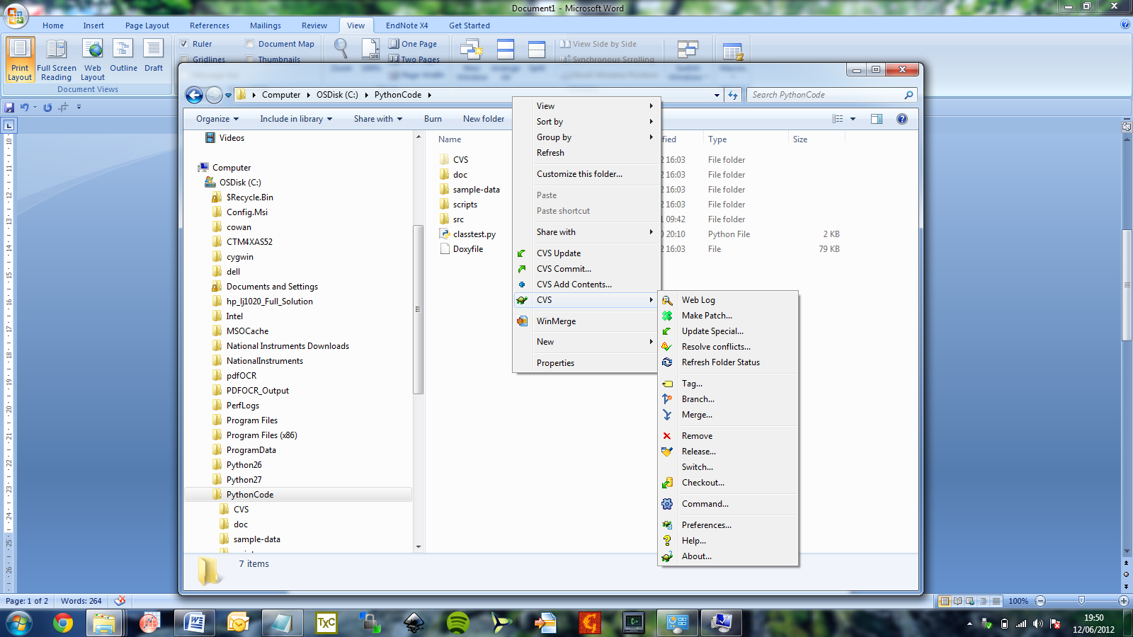
4. Go to preferences and edit them as follows:

In the policy tab tick the ‘permit sandboxes on network drives’ box

In the tools tab change merge app to your installed WinMergeU.exe

Change the SSH param to -l "%u" "%h" -i "C:\Windows\CVS-Server-Key.PPK" (or wherever you saved it earlier)

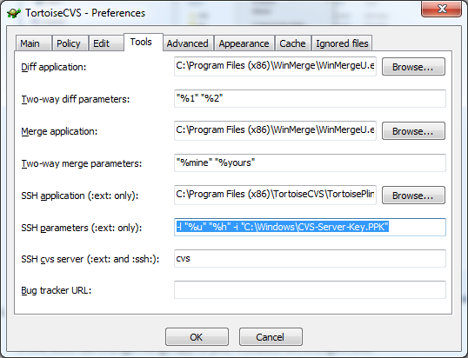

1. Your final step is to ‘checkout’ the latest version of Stoner module from the server. Right click in your PythonCode folder and go to CVS/Checkout
2. As shown in the print screen change your CVSROOT to :ext:cvs@stonerlab.leeds.ac.uk:/home/cvs, then type in PythonCode into the Module box, then click OK.
3. This should now update your Stoner module. If you make changes to the Stoner code or documentation in the future you can update the server copy by doing right click CVS update. 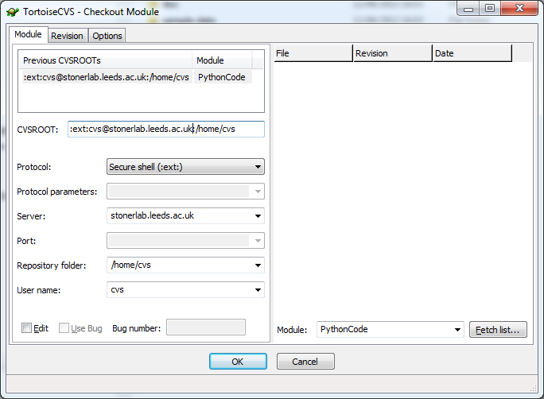
4. For further instructions on using the Stoner module consult the user guide in PythonCode/docs/